**NAME: PATEL JAIMINI SHAILESHKUMAR**

**ROLLNO: 37**

**SYMCA-SEM-IV**

**SUBJECT: IMAGE PROCESSING AND COMPUTER VISION**

**Ex no: 1**

**Date: 02-1-2020**

**Problem Statement:**

Display image

**Program:**

import cv2

import dlib

import numpy as np

img=cv2.imread('flower.jpg')

cv2.imshow('original',img)

cv2.waitkey(0)

cv2.destoryAllwindows()

**Output:**

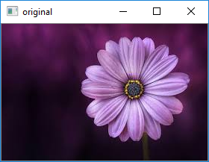

**Ex no: 2**

**Date: 12-12-2019**

**Problem Statement:**

Write a Python graphics program to print your fullname in Hindi using basic shapes.

**Program:**

from graphics import *

w=GraphWin("Hindi Name",700,700)

l=Line(Point(0,10),Point(700,10))

l.draw(w)

l.setWidth(3)

l.setOutline("blue")

l=Line(Point(0,550),Point(700,550))

l.draw(w)

l.setWidth(3)

l.setOutline("blue")

w.setBackground('black')

#Jai

l=Line(Point(260,100),Point(550,100))

l.draw(w)

l.setWidth(3)

l.setOutline("blue")

l=Line(Point(280,145),Point(340,145))

l.draw(w)

l.setWidth(3)

l.setOutline("blue")

l=Arc(Point(250,200),Point(290,110),10,-200,"arc")

l.draw(w)

l.setOutline("blue")

l.setWidth(3)

l=Line(Point(340,200),Point(340,100))

l.draw(w)

l.setWidth(3)

l.setOutline("blue")

l=Line(Point(250,45),Point(350,100))

l.draw(w)

l.setWidth(3)

l.setOutline("blue")

l=Line(Point(220,50),Point(320,100))

l.draw(w)

l.setWidth(3)

l.setOutline("blue")

#mi

l=Line(Point(430,200),Point(430,100))

l.draw(w)

l.setWidth(3)

l.setOutline("blue")

l=Line(Point(400,145),Point(430,145))

l.draw(w)

l.setWidth(3)

l.setOutline("blue")

l=Line(Point(400,170),Point(400,100))

l.draw(w)

l.setWidth(3)

l.setOutline("blue")

l=Arc(Point(400,180),Point(370,140),0,-340,"arc")

l.draw(w)

l.setOutline("blue")

l.setWidth(3)

l=Line(Point(450,200),Point(450,100))

l.draw(w)

l.setWidth(3)

l.setOutline("blue")

l=Arc(Point(450,130),Point(430,70),0,180,"arc")

l.draw(w)

l.setOutline("blue")

l.setWidth(3)

#ni

l=Line(Point(520,200),Point(520,100))

l.draw(w)

l.setWidth(3)

l.setOutline("blue")

l=Line(Point(490,147),Point(520,147))

l.draw(w)

l.setWidth(3)

l.setOutline("blue")

l=Arc(Point(490,170),Point(460,140),0,355,"arc")

l.draw(w)

l.setOutline("blue")

l.setWidth(3)

l=Line(Point(540,200),Point(540,100))

l.draw(w)

l.setWidth(3)

l.setOutline("blue")

l=Arc(Point(540,130),Point(520,70),0,180,"arc")

l.draw(w)

l.setOutline("blue")

l.setWidth(3)

#p

l=Line(Point(255,275),Point(480,275))

l.draw(w)

l.setWidth(3)

l.setOutline("blue")

l=Arc(Point(255,270),Point(300,316),140,182,"arc")

l.draw(w)

l.setOutline("blue")

l.setWidth(3)

l=Line(Point(295,277),Point(295,352))

l.draw(w)

l.setOutline("blue")

l.setWidth(3)

#t

l=Line(Point(355,277),Point(355,302))

l.draw(w)

l.setOutline("blue")

l.setWidth(3)

l=Arc(Point(320,300),Point(375,350),70,230,"arc")

l.draw(w)

l.setOutline("blue")

l.setWidth(3)

l=Line(Point(355,277),Point(325,240))

l.draw(w)

l.setOutline("blue")

l.setWidth(3)

#l

l=Line(Point(390,352),Point(376,315))

l.draw(w)

l.setOutline("blue")

l.setWidth(3)

l=Arc(Point(376,305),Point(402,325),-35,220,"arc")

l.draw(w)

l.setOutline("blue")

l.setWidth(3)

l=Arc(Point(400,305),Point(430,325),20,170,"arc")

l.draw(w)

l.setOutline("blue")

l.setWidth(3)

l=Line(Point(428,277),Point(428,352))

l.draw(w)

l.setOutline("blue")

l.setWidth(3)

**Output:**

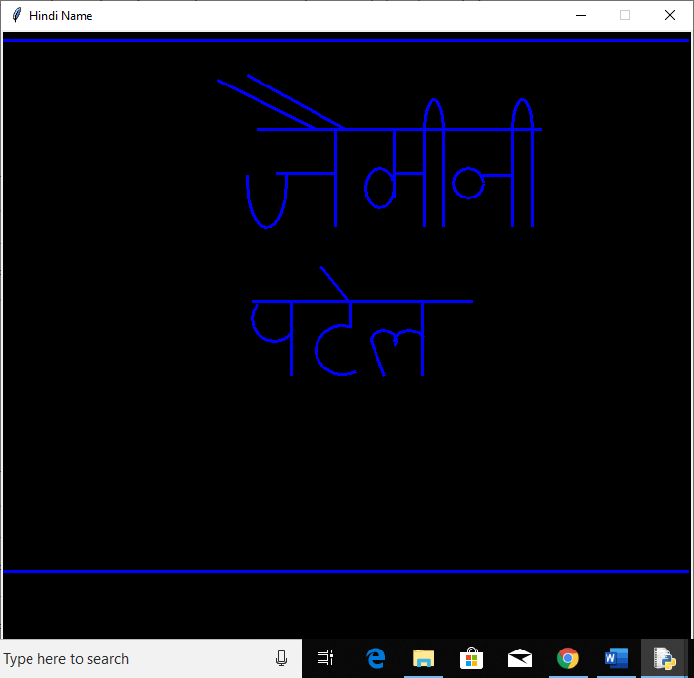

**Ex no: 3**

**Date: 12-12-2019**

**Problem Statement:**

Write a Python graphics program to print alphabets in both upper case and lower case letters using basic shapes.

**Capital letter**

**Program:**

from graphics import *

w=GraphWin("Alphabets(A-Z)",600,500)

l=Line(Point(0,10),Point(600,10))

l.draw(w)

l.setWidth(3)

l.setOutline("blue")

l=Line(Point(0,380),Point(650,380))

l.draw(w)

l.setWidth(3)

l.setOutline("blue")

w.setBackground("black")

a1=Line(Point(22,120),Point(40,20))

a2=Line(Point(60,120),Point(40,20))

a3=Line(Point(30,80),Point(50,80))

a1.setWidth(3)

a2.setWidth(3)

a3.setWidth(3)

a1.draw(w)

a2.draw(w)

a3.draw(w)

a1.setOutline("red")

a2.setOutline("red")

a3.setOutline("red")

b1=Line(Point(80,20),Point(80,120))

b2=Arc(Point(45,20),Point(120,70),270,180,"arc")

b3=Arc(Point(45,70),Point(120,120),270,180,"arc")

b1.setWidth(3)

b1.draw(w)

b2.draw(w)

b3.draw(w)

b2.setWidth(4)

b3.setWidth(4)

b1.setOutline("red")

b2.setOutline("red")

b3.setOutline("red")

c1=Arc(Point(140,20),Point(190,120),45,270,"arc")

c1.draw(w)

c1.setWidth(3)

c1.setOutline("red")

d1=Line(Point(200,20),Point(200,120))

d2=Arc(Point(160,20),Point(240,120),270,180,"arc")

d2.draw(w)

d2.setWidth(3)

d1.setWidth(3)

d1.draw(w)

d1.setOutline("red")

d2.setOutline("red")

e1=Line(Point(260,20),Point(260,120))

e2=Line(Point(260,20),Point(300,20))

e3=Line(Point(260,70),Point(290,70))

e4=Line(Point(260,120),Point(300,120))

e1.setWidth(3)

e2.setWidth(3)

e3.setWidth(3)

e4.setWidth(3)

e1.draw(w)

e2.draw(w)

e3.draw(w)

e4.draw(w)

e1.setOutline("red")

e2.setOutline("red")

e3.setOutline("red")

e4.setOutline("red")

f1=Line(Point(320,20),Point(320,120))

f2=Line(Point(320,20),Point(360,20))

f3=Line(Point(320,70),Point(350,70))

f1.setWidth(3)

f2.setWidth(3)

f3.setWidth(3)

f1.draw(w)

f2.draw(w)

f3.draw(w)

f1.setOutline("red")

f2.setOutline("red")

f3.setOutline("red")

g1=Arc(Point(370,20),Point(420,120),45,300,"arc")

g2=Line(Point(400,80),Point(430,80))

g3=Line(Point(420,80),Point(420,120))

g1.draw(w)

g1.setWidth(3)

g2.setWidth(3)

g3.setWidth(3)

g2.draw(w)

g3.draw(w)

g1.setOutline("red")

g2.setOutline("red")

g3.setOutline("red")

h1=Line(Point(440,20),Point(440,120))

h2=Line(Point(440,70),Point(480,70))

h3=Line(Point(480,20),Point(480,120))

h1.setWidth(3)

h2.setWidth(3)

h3.setWidth(3)

h1.draw(w)

h2.draw(w)

h3.draw(w)

h1.setOutline("red")

h2.setOutline("red")

h3.setOutline("red")

i1=Line(Point(520,20),Point(520,120))

i2=Line(Point(510,20),Point(530,20))

i3=Line(Point(510,120),Point(530,120))

i1.setWidth(3)

i2.setWidth(3)

i3.setWidth(3)

i1.draw(w)

i2.draw(w)

i3.draw(w)

i1.setOutline("red")

i2.setOutline("red")

i3.setOutline("red")

j1=Line(Point(580,20),Point(580,115))

j2=Line(Point(560,20),Point(600,20))

j3=Arc(Point(555,100),Point(580,120),160,180,"arc")

j3.draw(w)

j3.setWidth(3)

j1.setWidth(3)

j2.setWidth(3)

j1.draw(w)

j2.draw(w)

j1.setOutline("red")

j2.setOutline("red")

j3.setOutline("red")

k1=Line(Point(20,140),Point(20,240))

k2=Line(Point(60,140),Point(20,190))

k3=Line(Point(20,190),Point(60,240))

k1.setWidth(3)

k2.setWidth(3)

k3.setWidth(3)

k1.draw(w)

k2.draw(w)

k3.draw(w)

k1.setOutline("red")

k2.setOutline("red")

k3.setOutline("red")

l=Line(Point(0,130),Point(650,130))

l.draw(w)

l.setWidth(3)

l.setOutline("pink")

l1=Line(Point(80,140),Point(80,240))

l2=Line(Point(80,240),Point(120,240))

l1.setWidth(3)

l2.setWidth(3)

l1.draw(w)

l2.draw(w)

l1.setOutline("red")

l2.setOutline("red")

m1=Line(Point(140,140),Point(140,240))

m2=Line(Point(140,140),Point(160,190))

m3=Line(Point(160,190),Point(180,140))

m4=Line(Point(180,140),Point(180,240))

m1.setWidth(3)

m2.setWidth(3)

m3.setWidth(3)

m4.setWidth(3)

m1.draw(w)

m2.draw(w)

m3.draw(w)

m4.draw(w)

m1.setOutline("red")

m2.setOutline("red")

m3.setOutline("red")

m4.setOutline("red")

n1=Line(Point(200,140),Point(200,240))

n2=Line(Point(200,140),Point(240,240))

n3=Line(Point(240,140),Point(240,240))

n1.setWidth(3)

n2.setWidth(3)

n3.setWidth(3)

n1.draw(w)

n2.draw(w)

n3.draw(w)

n1.setOutline("red")

n2.setOutline("red")

n3.setOutline("red")

o=Oval(Point(260,140),Point(300,240))

o.setWidth(3)

o.draw(w)

o.setOutline("red")

p1=Line(Point(320,140),Point(320,240))

p2=Arc(Point(285,140),Point(360,190),270,180,"arc")

p2.draw(w)

p2.setWidth(3)

p1.setWidth(3)

p1.draw(w)

p1.setOutline("red")

p2.setOutline("red")

q1=Oval(Point(370,140),Point(420,240))

q2=Line(Point(400,220),Point(420,250))

q1.setWidth(3)

q1.draw(w)

q2.setWidth(3)

q2.draw(w)

q1.setOutline("red")

q2.setOutline("red")

r1=Line(Point(440,140),Point(440,240))

r2=Arc(Point(405,140),Point(480,190),270,180,"arc")

r3=Line(Point(440,190),Point(480,240))

r2.draw(w)

r2.setWidth(3)

r1.setWidth(3)

r1.draw(w)

r3.setWidth(3)

r3.draw(w)

r1.setOutline("red")

r2.setOutline("red")

r3.setOutline("red")

s1=Arc(Point(500,140),Point(540,193),60,210,"arc")

s1.draw(w)

s1.setWidth(3)

s2=Arc(Point(490,192),Point(530,240),65,-210,"arc")

s2.draw(w)

s2.setWidth(3)

s1.setOutline("red")

s2.setOutline("red")

t1=Line(Point(560,140),Point(600,140))

t1.draw(w)

t1.setWidth(3)

t2=Line(Point(580,140),Point(580,240))

t2.draw(w)

t2.setWidth(3)

t1.setOutline("red")

t2.setOutline("red")

l=Line(Point(0,250),Point(650,250))

l.draw(w)

l.setWidth(3)

l.setOutline("pink")

u1=Line(Point(20,260),Point(20,330))

u1.draw(w)

u1.setWidth(3)

u2=Line(Point(70,260),Point(70,330))

u2.draw(w)

u2.setWidth(3)

u3=Arc(Point(20,300),Point(70,360),180,180,"arc")

u3.draw(w)

u3.setWidth(3)

u1.setOutline("red")

u2.setOutline("red")

u3.setOutline("red")

v1=Line(Point(90,260),Point(110,360))

v1.draw(w)

v1.setWidth(3)

v2=Line(Point(110,360),Point(130,260))

v2.draw(w)

v2.setWidth(3)

v1.setOutline("red")

v2.setOutline("red")

w1=Line(Point(150,260),Point(170,360))

w1.draw(w)

w1.setWidth(3)

w2=Line(Point(170,360),Point(190,260))

w2.draw(w)

w2.setWidth(3)

w3=Line(Point(190,260),Point(210,360))

w3.draw(w)

w3.setWidth(3)

w4=Line(Point(210,360),Point(230,260))

w4.draw(w)

w4.setWidth(3)

w1.setOutline("red")

w2.setOutline("red")

w3.setOutline("red")

w4.setOutline("red")

x1=Line(Point(250,260),Point(290,360))

x1.draw(w)

x1.setWidth(3)

x2=Line(Point(290,260),Point(250,360))

x2.draw(w)

x2.setWidth(3)

x1.setOutline("red")

x2.setOutline("red")

y1=Line(Point(310,260),Point(330,310))

y1.draw(w)

y1.setWidth(3)

y2=Line(Point(350,260),Point(330,310))

y2.draw(w)

y2.setWidth(3)

y3=Line(Point(330,310),Point(330,360))

y3.draw(w)

y3.setWidth(3)

y1.setOutline("red")

y2.setOutline("red")

y3.setOutline("red")

z1=Line(Point(370,260),Point(410,260))

z1.draw(w)

z1.setWidth(3)

z2=Line(Point(370,360),Point(410,360))

z2.draw(w)

z2.setWidth(3)

z3=Line(Point(410,260),Point(370,360))

z3.draw(w)

z3.setWidth(3)

z1.setOutline("red")

z2.setOutline("red")

z3.setOutline("red")

**Output:**

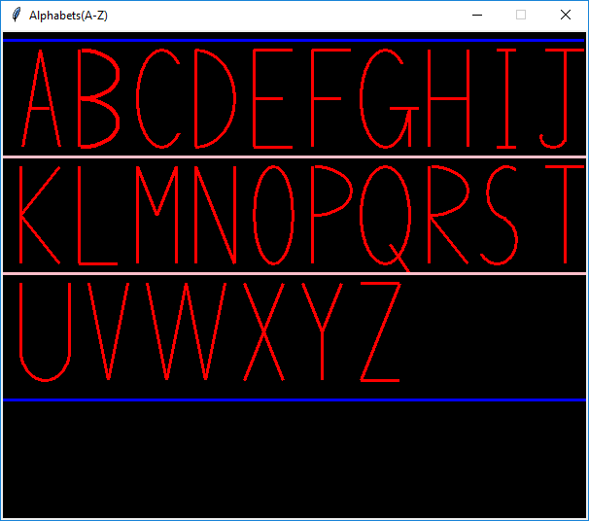

**Lower Case**

**Program:**

from graphics import *

w=GraphWin("Small Alphabets(a-z",640,600)

l=Line(Point(0,10),Point(640,10))

l.draw(w)

l.setWidth(3)

l.setOutline("red")

l=Line(Point(0,550),Point(650,550))

l.draw(w)

l.setWidth(3)

l.setOutline("red")

w.setBackground("black")

w.setBackground("black")

a1=Arc(Point(45,60),Point(95,120),40,280,"arc")

a1.draw(w)

a1.setWidth(3)

a1.setOutline("blue")

a2=Line(Point(90,60),Point(90,120))

a2.draw(w)

a2.setWidth(3)

a2.setOutline("blue")

a3=Arc(Point(90,115),Point(102,125),180,180,"arc")

a3.draw(w)

a3.setWidth(3)

a3.setOutline("blue")

b1=Line(Point(125,10),Point(125,120))

b1.draw(w)

b1.setWidth(3)

b1.setOutline("blue")

b2=Arc(Point(120,60),Point(170,120),140,-280,"arc")

b2.draw(w)

b2.setWidth(3)

b2.setOutline("blue")

c=Arc(Point(190,60),Point(240,120),50,260,"arc")

c.draw(w)

c.setWidth(3)

c.setOutline("blue")

d1=Line(Point(290,10),Point(290,120))

d1.draw(w)

d1.setWidth(3)

d1.setOutline("blue")

d2=Arc(Point(245,60),Point(295,120),40,280,"arc")

d2.draw(w)

d2.setWidth(3)

d2.setOutline("blue")

e1=Arc(Point(310,60),Point(360,120),45,300,"arc")

e1.draw(w)

e1.setWidth(3)

e1.setOutline("blue")

e2=Arc(Point(290,50),Point(350,90),10,-120,"arc")

e2.draw(w)

e2.setWidth(3)

e2.setOutline("blue")

f1=Line(Point(380,20),Point(380,120))

f1.draw(w)

f1.setWidth(3)

f1.setOutline("blue")

f2=Arc(Point(380,5),Point(410,35),0,180,"arc")

f2.draw(w)

f2.setWidth(3)

f2.setOutline("blue")

f3=Line(Point(380,60),Point(400,60))

f3.draw(w)

f3.setWidth(3)

f3.setOutline("blue")

g1=Line(Point(460,60),Point(460,140))

g1.draw(w)

g1.setWidth(3)

g1.setOutline("blue")

g2=Arc(Point(415,60),Point(465,120),40,280,"arc")

g2.draw(w)

g2.setWidth(3)

g2.setOutline("blue")

g3=Arc(Point(460,120),Point(415,160),0,-160,"arc")

g3.draw(w)

g3.setWidth(3)

g3.setOutline("blue")

h1=Line(Point(490,10),Point(490,120))

h1.draw(w)

h1.setWidth(3)

h1.setOutline("blue")

h2=Arc(Point(490,60),Point(530,100),0,180,"arc")

h2.draw(w)

h2.setWidth(3)

h2.setOutline("blue")

h3=Line(Point(530,80),Point(530,120))

h3.draw(w)

h3.setWidth(3)

h3.setOutline("blue")

i1=Line(Point(560,60),Point(560,120))

i1.draw(w)

i1.setWidth(3)

i1.setOutline("blue")

i2=Circle(Point(560,40),3)

i2.draw(w)

i2.setWidth(3)

i2.setOutline("blue")

j1=Line(Point(590,60),Point(590,150))

j1.draw(w)

j1.setWidth(3)

j1.setOutline("blue")

j2=Circle(Point(590,40),3)

j2.draw(w)

j2.setWidth(3)

j2.setOutline("blue")

j3=Arc(Point(590,130),Point(570,160),0,-90,"arc")

j3.draw(w)

j3.setWidth(3)

j3.setOutline("blue")

l1=Line(Point(0,180),Point(640,180))

l2=Line(Point(0,360),Point(640,360))

l1.draw(w)

l2.draw(w)

l1.setWidth(3)

l2.setWidth(3)

l1.setOutline("green")

l2.setOutline("green")

k1=Line(Point(50,190),Point(50,300))

k1.draw(w)

k1.setWidth(3)

k1.setOutline("blue")

k2=Line(Point(80,240),Point(50,270))

k2.draw(w)

k2.setWidth(3)

k2.setOutline("blue")

k3=Line(Point(60,260),Point(80,300))

k3.draw(w)

k3.setWidth(3)

k3.setOutline("blue")

l1=Line(Point(110,190),Point(110,300))

l1.draw(w)

l1.setWidth(3)

l1.setOutline("blue")

l2=Arc(Point(130,280),Point(110,310),180,90,"arc")

l2.draw(w)

l2.setWidth(3)

l2.setOutline("blue")

m1=Line(Point(150,240),Point(150,300))

m1.draw(w)

m1.setWidth(3)

m1.setOutline("blue")

m2=Arc(Point(150,240),Point(180,270),180,-200,"arc")

m2.draw(w)

m2.setWidth(3)

m2.setOutline("blue")

m3=Line(Point(180,260),Point(180,300))

m3.draw(w)

m3.setWidth(3)

m3.setOutline("blue")

m4=Arc(Point(180,240),Point(210,270),180,-200,"arc")

m4.draw(w)

m4.setWidth(3)

m4.setOutline("blue")

m5=Line(Point(210,250),Point(210,300))

m5.draw(w)

m5.setWidth(3)

m5.setOutline("blue")

n1=Line(Point(240,240),Point(240,300))

n1.draw(w)

n1.setWidth(3)

n1.setOutline("blue")

n2=Arc(Point(240,240),Point(270,270),180,-200,"arc")

n2.draw(w)

n2.setWidth(3)

n2.setOutline("blue")

n3=Line(Point(270,260),Point(270,300))

n3.draw(w)

n3.setWidth(3)

n3.setOutline("blue")

o=Oval(Point(290,240),Point(340,300))

o.draw(w)

o.setWidth(3)

o.setOutline("blue")

p1=Line(Point(360,240),Point(360,340))

p1.draw(w)

p1.setWidth(3)

p1.setOutline("blue")

p2=Arc(Point(355,240),Point(405,300),140,-280,"arc")

p2.draw(w)

p2.setWidth(3)

p2.setOutline("blue")

q1=Line(Point(470,240),Point(470,350))

q1.draw(w)

q1.setWidth(3)

q1.setOutline("blue")

q2=Arc(Point(425,240),Point(475,300),40,280,"arc")

q2.draw(w)

q2.setWidth(3)

q2.setOutline("blue")

q3=Line(Point(470,350),Point(500,300))

q3.draw(w)

q3.setWidth(3)

q3.setOutline("blue")

r1=Line(Point(520,240),Point(520,300))

r1.draw(w)

r1.setWidth(3)

r1.setOutline("blue")

r2=Arc(Point(520,242),Point(580,258),180,-100,"arc")

r2.draw(w)

r2.setWidth(3)

r2.setOutline("blue")

s1=Arc(Point(580,240),Point(610,270),25,260,"arc")

s1.draw(w)

s1.setWidth(3)

s1.setOutline("blue")

s2=Arc(Point(580,270),Point(610,300),105,-270,"arc")

s2.draw(w)

s2.setWidth(3)

s2.setOutline("blue")

t1=Line(Point(50,370),Point(50,470))

t1.draw(w)

t1.setWidth(3)

t1.setOutline("blue")

t2=Arc(Point(50,450),Point(70,480),180,120,"arc")

t2.draw(w)

t2.setWidth(3)

t2.setOutline("blue")

t3=Line(Point(40,420),Point(60,420))

t3.draw(w)

t3.setWidth(3)

t3.setOutline("blue")

u1=Line(Point(100,420),Point(100,470))

u1.draw(w)

u1.setWidth(3)

u1.setOutline("blue")

u2=Arc(Point(100,450),Point(130,480),170,200,"arc")

u2.draw(w)

u2.setWidth(3)

u2.setOutline("blue")

u3=Line(Point(130,420),Point(130,480))

u3.draw(w)

u3.setWidth(3)

u3.setOutline("blue")

v1=Line(Point(160,420),Point(175,480))

v1.draw(w)

v1.setWidth(3)

v1.setOutline("blue")

v2=Line(Point(190,420),Point(175,480))

v2.draw(w)

v2.setWidth(3)

v2.setOutline("blue")

w1=Line(Point(220,420),Point(235,480))

w1.draw(w)

w1.setWidth(3)

w1.setOutline("blue")

w2=Line(Point(250,420),Point(235,480))

w2.draw(w)

w2.setWidth(3)

w2.setOutline("blue")

w3=Line(Point(250,420),Point(265,480))

w3.draw(w)

w3.setWidth(3)

w3.setOutline("blue")

w4=Line(Point(280,420),Point(265,480))

w4.draw(w)

w4.setWidth(3)

w4.setOutline("blue")

x1=Line(Point(310,420),Point(340,480))

x1.draw(w)

x1.setWidth(3)

x1.setOutline("blue")

x2=Line(Point(340,420),Point(310,480))

x2.draw(w)

x2.setWidth(3)

x2.setOutline("blue")

y1=Line(Point(370,420),Point(390,480))

y1.draw(w)

y1.setWidth(3)

y1.setOutline("blue")

y2=Line(Point(410,420),Point(380,515))

y2.draw(w)

y2.setWidth(3)

y2.setOutline("blue")

y3=Arc(Point(360,510),Point(380,520),0,-110,"arc")

y3.draw(w)

y3.setWidth(3)

y3.setOutline("blue")

z1=Line(Point(440,420),Point(480,420))

z1.draw(w)

z1.setWidth(3)

z1.setOutline("blue")

z2=Line(Point(480,420),Point(440,480))

z2.draw(w)

z2.setWidth(3)

z2.setOutline("blue")

z3=Line(Point(440,480),Point(480,480))

z3.draw(w)

z3.setWidth(3)

z3.setOutline("blue")

**Output:**

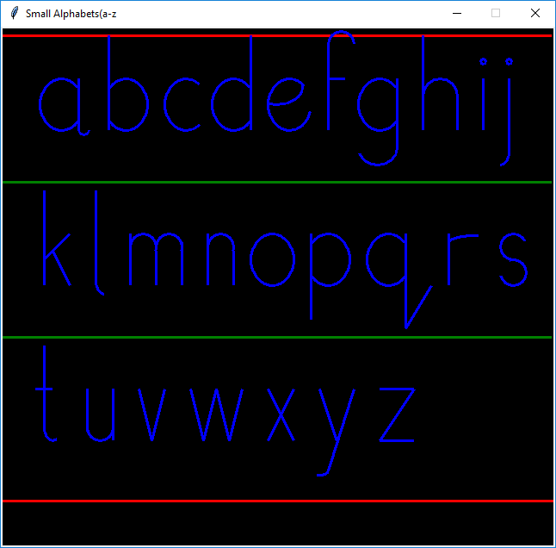

**Ex no: 4**

**Date: 4-12-2019**

**Problem Statement:**

Draw the Target symbol (a set of concentric circles, alternating red and white) in a graphics window that is 200 pixels wide by 200 pixels high. Hint: Draw the largest circle first in red, then draw the next smaller circle in white, then draw the next smaller circle in red.

**Program:**

from graphics import *

w=GraphWin("Shapes",700,700)

label=Text(Point(300,20),"Circle")

label.draw(w)

label.setStyle("bold")

center=Point(400,400)

circ=Circle(center,270)

circ.setFill("red")

circ.setWidth(3)

circ.draw(w)

center=Point(410,400)

circ=Circle(center,180)

circ.setFill("white")

circ.setWidth(3)

circ.draw(w)

center=Point(420,400)

circ=Circle(center,90)

circ.setFill("red")

circ.setWidth(3)

circ.draw(w)

**Output:**

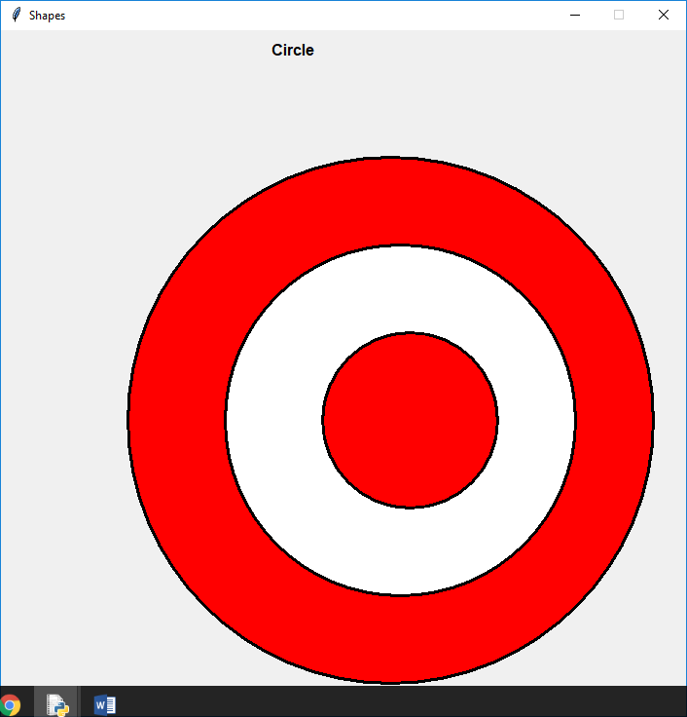

**Ex no: 5**

**Date: 4-12-2019**

**Problem Statement:**

Draw a simple traffic light in a graphics window that is 200 pixels wide by 200 pixels high. The three lights should have a diameter of 50 pixels each, and the traffic light should be centered in the graphics window.

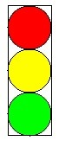

**Program:**

from graphics import *

w=GraphWin("Shapes",200,200)

label=Text(Point(50,10),"Traffic light")

label.draw(w)

label.setStyle("bold")

rect=Rectangle(Point(20,20),Point(80,200))

rect.draw(w)

rect.setWidth(3)

center=Point(50,50)

circ=Circle(center,30)

circ.setFill("red")

circ.setWidth(3)

circ.draw(w)

center=Point(50,110)

circ=Circle(center,30)

circ.setFill("yellow")

circ.setWidth(3)

circ.draw(w)

center=Point(50,170)

circ=Circle(center,30)

circ.setFill(color_rgb(0,255,0))

circ.setWidth(3)

circ.draw(w)

**Output:**

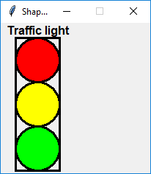

**Ex no: 6**

**Date: 4-12-2019**

**Problem Statement:**

Create the image shown below.

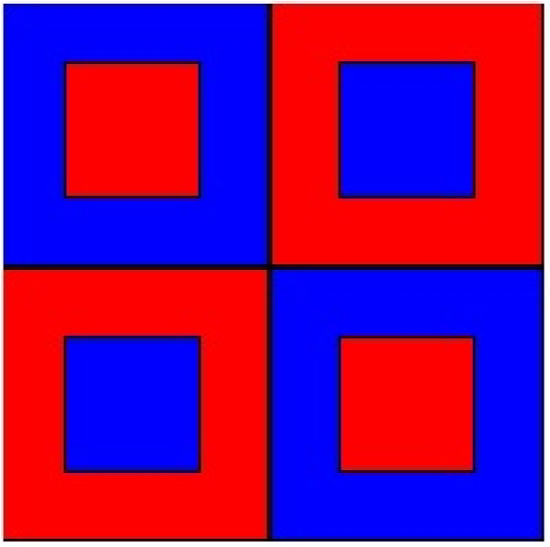

**Program:**

from graphics import *

w=GraphWin("line Drawing",600,600)

rect=Rectangle(Point(0,0),Point(300,300))

rect.setWidth(5)

rect.draw(w)

rect.setFill("blue")

rect=Rectangle(Point(75,75),Point(225,225))

rect.setWidth(5)

rect.draw(w)

rect.setFill("red")

rect=Rectangle(Point(300,0),Point(600,300))

rect.setWidth(5)

rect.draw(w)

rect.setFill("red")

rect=Rectangle(Point(375,75),Point(525,225))

rect.setWidth(5)

rect.draw(w)

rect.setFill("blue")

rect=Rectangle(Point(0,300),Point(300,600))

rect.setWidth(5)

rect.draw(w)

rect.setFill("red")

rect=Rectangle(Point(75,375),Point(225,525))

rect.setWidth(5)

rect.draw(w)

rect.setFill("blue")

rect=Rectangle(Point(300,300),Point(600,600))

rect.setWidth(5)

rect.draw(w)

rect.setFill("blue")

rect=Rectangle(Point(375,375),Point(525,525))

rect.setWidth(5)

rect.draw(w)

rect.setFill("red")

**Output:**

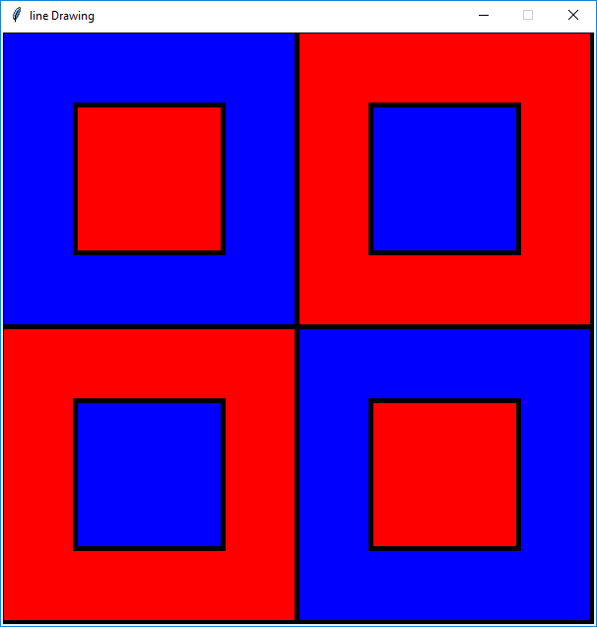

**Ex no: 7**

**Date: 12-12-2019**

**Problem Statement:**

Create a checkerboard of white and black squares in a graphics window that is 200 pixels wide by 200 pixels high. Each square should be 25 X 25. Can you simplify this program using loops?

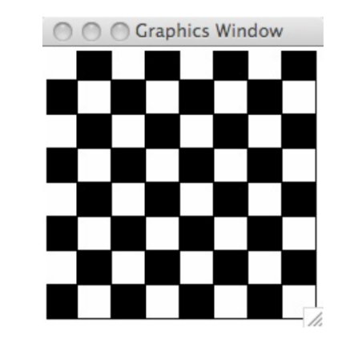

**Program:**

from graphics import *

w=GraphWin("chessboard",700,700)

label=Text(Point(300,50),"ChessBoard")

label.draw(w)

a="black"

b="white"

x=100

y=100

for j in range(8):

for i in range(8):

l=Rectangle(Point(x,y),Point(x+50,y+50))

l.draw(w)

if (i+j)%2!=0:

l.setFill(a)

else:

l.setFill(b)

x=x+50

y=y+50

x=100

**Output:**

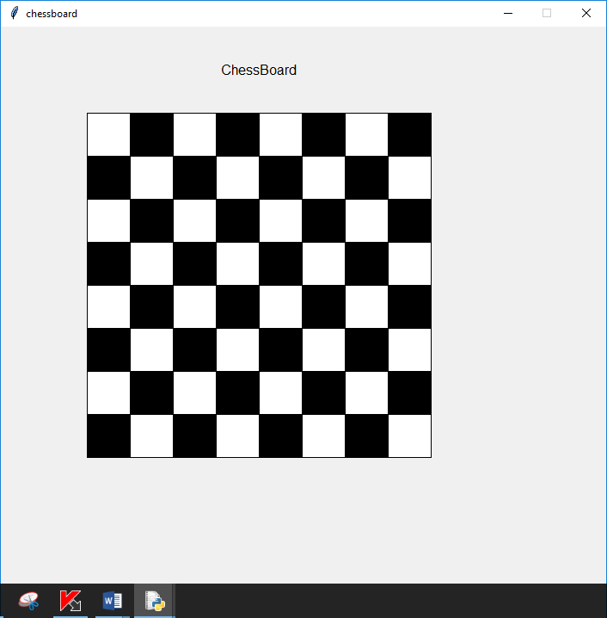

**Ex no: 8**

**Date: 19-12-2019**

**Problem Statement:**

Write a Python program to show Snowman using basic shapes

**Program:**

from graphics import*

x=400

y=500

win=GraphWin("Snowman",x,y)

label=Text(Point(70,70),"Snowman")

label.draw(win)

label.setStyle("bold")

label.setTextColor("red")

rect=Rectangle(Point(166,30),Point(218,70))

rect.draw(win)

rect.setFill("blue")

#big circle

center=Point(190,230)

circ=Circle(center,80)

circ.draw(win)

circ.setFill("white")

circ.setOutline("white")

#scraf

r=Polygon(Point(150,150),Point(140,160),

Point(150,180),Point(200,130))

# Point(180,150),Point(190,160))

r.setFill("lightgreen")

r.setWidth(3)

r.setOutline("lightgreen")

r.draw(win)

r=Oval(Point(150,170),Point(230,130))

r.draw(win)

r.setFill("pink")

r.setWidth(3)

r.setOutline("lightgreen")

#small circle

center=Point(190,117)

circ=Circle(center,40)

circ.draw(win)

circ.setOutline("white")

circ.setFill("white")

rect=Rectangle(Point(145,70),Point(237,80))

rect.draw(win)

rect.setFill("blue")

#left eye

center=Point(170,107)

circ=Circle(center,7)

circ.setFill('black')

circ.draw(win)

#right eye

center=Point(210,107)

circ=Circle(center,7)

circ.setFill('black')

circ.draw(win)

#nose

l=Line(Point(185,115),Point(200,118))

l.draw(win)

l.setFill("orange")

l.setWidth(5)

l=Line(Point(200,116),Point(182,130))

l.draw(win)

l.setFill("orange")

l.setWidth(5)

#smile

r=Arc(Point(160,57),Point(221,137),230,80,"arc")

r.draw(win)

r.setWidth(5)

#buttons

center=Point(190,200)

circ=Circle(center,8)

circ.setFill('red')

circ.draw(win)

center=Point(190,230)

circ=Circle(center,8)

circ.setFill('blue')

circ.draw(win)

center=Point(190,260)

circ=Circle(center,8)

circ.setFill('green')

circ.draw(win)

win.setBackground('black')

**Output:**

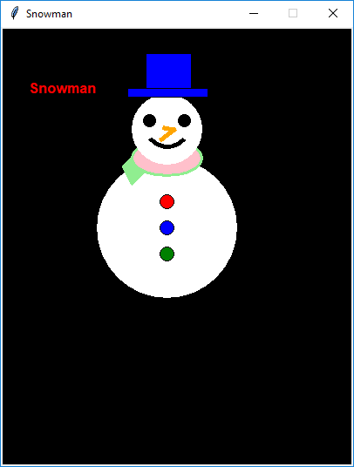

**Ex no: 9**

**Date: 19-12-2019**

**Problem Statement:**

Write a Python program to show House using basic shapes

**Program:**

from graphics import *

w=GraphWin("house",800,700)

triangle=Polygon(Point(370,420),Point(420,370),Point(470,420))

triangle.setFill('brown')

triangle.setWidth(4)

triangle.draw(w)

w.setBackground(color_rgb(153,217,255))

center=Point(0,100)

circ=Circle(center,200)

circ.setFill('yellow')

circ.draw(w)

rect=Rectangle(Point(370,570),Point(470,420))

rect.setFill(color_rgb(255,128,0))

rect.draw(w)

rect.setWidth(3)

rect=Rectangle(Point(470,570),Point(680,420))

rect.setFill(color_rgb(255,128,0))

rect.setWidth(3)

rect.draw(w)

rect=Rectangle(Point(540,540),Point(614,470))

rect.setFill('brown')

rect.draw(w)

rect.setWidth(3)

rect=Rectangle(Point(390,520),Point(450,450))

rect.setFill(color_rgb(24,168,216))

rect.draw(w)

rect.setWidth(3)

line=Line(Point(418,520),Point(418,450))

line.setWidth(3)

line.draw(w)

line=Line(Point(390,485),Point(450,485))

line.setWidth(3)

line.draw(w)

t=Polygon(Point(420,370),Point(620,370),Point(680,420))

t.setFill('brown')

t.setWidth(3)

t.draw(w)

t=Polygon(Point(420,370),Point(680,420),Point(470,420))

t.setFill('brown')

t.setWidth(3)

t.draw(w)

center=Point(550,530)

circ=Circle(center,4)

circ.setFill(color_rgb(255,242,0))

circ.draw(w)

**Output:**

